**DIGITAL OBJECT COUNTER**

by

A. Chaithanya Gopi - 13BCE1011

D. Shashank - 13BCE1036

K. Gourav - 13BCE1068

P. Sundeep - 13BCE1089

S. Chanakya - 13BCE1162

*A project report submitted to the*

**SCHOOL OF ELECTRICAL AND ELECTRONICS ENGINEERING**

*In partial fulfillment of the award for degree*

*of*

**BACHELOR OF TECHNOLOGY**

*in*

**COMPUTER SCIENCE ENGINEERING**



**VIT UNIVERSITY, CHENNAI**

**Vandalur – Kelambakkam Road**

**Chennai – 600 127.**

**OCTOBER 2014**

**BONAFIDE CERTIFICATE**

Certified that this project report entitled “**DIGITAL OBJECT COUNTER”** is a bonafide work of **CHAITHANYA GOPI. A (13BCE1011), SHASHANK. D (13BCE1036), GOURAV. K (13BCE1068), SUNDEEP. P (13BCE1089) and CHANAKYA. S (13BCE1162)** who carried out the Project work under my supervision and guidance.

**Dr. SANGEETHA. R**

Associate Professor

School of Electronics Engineering (SELECT),

VIT University, Chennai

**ABSTRACT**

A counter machine is an abstract machine used in formal logic and theoretical computer science to model computation. In more understandable way, it is a device which calculates the number of objects fed to its sensor and displays accordingly. The main idea on which the circuit works is the detection of absence of light by the Light Dependent Resistor and displaying the output through the seven segment display. A digital object counter is designed with simple means of appliances and very basic integrated circuits to decrease the complexity of the circuit. It has many applications. For example, an automaton is a leading step in changing the traditional techniques. Automating a system not only saves time but also saves resources and man power. Just assume that if a company has a worker employed only for counting the finished products and if the worker is replaced by a digital automatic system, then the chance of false counting, errors etc. factors are reduced. The digital system hence thereby with more efficiency reduces man power and increases accuracy. The digital object counter using LDR (Light Dependent Resistor) is a simple system which can be used for counting objects in the product manufacturing area of an industry etc. , not only this but also there are many applications of digital object counter. Two IC555 are used in Monostable and Astable mode for respective pulse generation. The counter IC7490 is a decade counter which is used for generating the 0-9 BCD code. The IC7447 is used for driving the 7 segment display. As the light is blocked, a pulse is generated and given to the decade counter. It increments and generates the code and the number is displayed on the 7 segment display. This constitutes the whole digital object counter system and is at a very low cost and effective product.

**ACKNOWLEDGEMENT**

We wish to express our sincere thanks and deep sense of gratitude to our project guide, **Dr. Sangeetha R,** Associate Professor, School of Electrical And Electronics Engineering, for her consistent encouragement and valuable guidance offered to us in a pleasant manner throughout the course of the project work.

We are extremely grateful to **Dr. Hemamalini,** Dean of the School of Electrical and Electronics Engineering, VIT University, for extending the facilities of the School towards our project and for her unstinting support.

We also take this opportunity to thank all the faculty of the School for their support and their wisdom imparted to us throughout the course.

We thank our parents, family, and friends for bearing with us throughout the course of our project and for the opportunity they provided us in undergoing this course in such a prestigious institution.

**Shashank. D Gourav. K Sundeep. P Chaithanya. A Chanakya. S**

**TABLE OF CONTENTS**

1. Introduction
2. Components Required
3. Circuit Diagram
4. Working Principle
5. LDR
6. IC7490 Decade Counter
7. IC7447
8. IC555
9. Seven Segment Display

**INTRODUCTION**

A counter machine is an abstract machine used in formal logic and theoretical computer science to model computation. In more understandable way, it is a device which calculates the number of objects fed to its sensor and displays accordingly.

The main idea on which the circuit works is the detection of absence of light by the Light Dependent Resistor and displaying the output through the seven segment display.

Two IC555 are used in Monostable and Astable mode for respective pulse generation. The counter IC7490 is a decade counter which is used for generating the 0-9 BCD code. The IC7447 is used for driving the 7 segment display. As the light is blocked, a pulse is generated and given to the decade counter. It increments and generates the code and the number is displayed on the 7 segment display. This constitutes the whole digital object counter system and is at a very low cost and effective product.

**COMPONENTS REQUIRED**

**1) IC 7490 Decade counter. - X 1**

**2) IC 7447. - X 1**

**3) IC 555 Timer. - X 2**

**4) Common Anode 7 segment display. - X 1**

**5) Light Dependent Resistor (LDR). - X 1**

**6) Rheostat (Variable resistor) – 100k ohm - X 1**

**7) Resistors:**

**1k ohm - X 1**

**330 ohm - X 9**

**100k ohm - X 1**

**47k ohm - X 1**

**8) Capacitors:**

**10 µF - X 2**

**0.01 µF - X 1**

**9) Light Emitting Diodes (LED) - X 2**

**10) 6V Battery for power supply - X 1**

**11) Connecting Wires - X 1**

**12) Bread boards - X 2**

**CIRCUIT DIAGRAM**

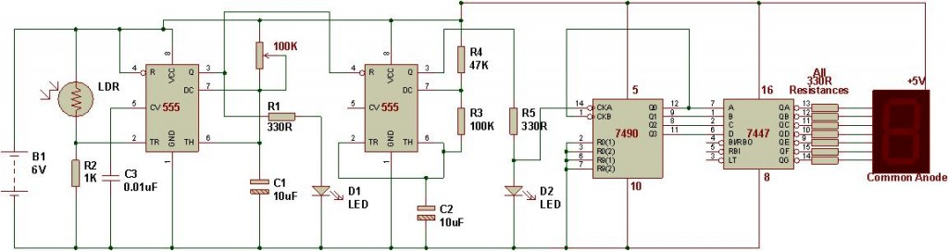

**WORKING PRINCIPLE**

Digital Object Counter mainly has four units:

1. Primary sensing unit (L.D.R)

2. IC 555 one in monostable mode and another one in astable mode.

3. Counting unit (Decade counter IC 7490)

4. Binary to 7-segment display conversion unit (IC 7447)

5. Display unit (common anode seven segment display)

IC 555 timer configured in monostable mode is a simple automatic dark sensor circuit that gives output when light falling on LDR is blocked.

Pin 3 of monostable circuit has been connected to pin 4 of astable timer. When monostable circuit generates output, astable mode timer starts giving pulses to the counter module.

Frequency for counter module is set up using R4, R3 and C2.

7490 acts as a decade counter and 7447 uses the output of 7490 to display numbers on seven segment display.

This circuit counts from 0 to 9.

**LDR (LIGHT DEPENDENT RESISTOR)**

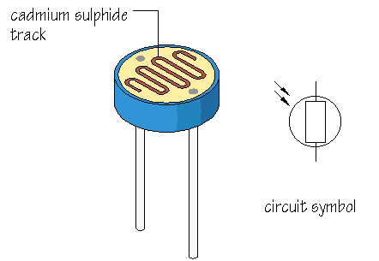

A **photo resistor** or **light dependent resistor** (**LDR**) is a resistor whose resistance decreases with increasing incident light intensity i.e. it exhibits *photoconductivity*.

A photo resistor is made of a high resistance semiconductor.

If light falling on the device is of high order, then enough frequency photons absorbed by the semiconductor device which give bound electrons enough energy to jump into the conduction band. The resulting free electron and its hole partner conduct electricity, thereby lowering resistance.

Inexpensive cadmium sulphide cells can be found in many consumer items such as camera light meters, street lights, clock radios, alarm devices, outdoor clocks, solar street lamps and solar road studs, etc.

They are also used in some dynamic compressors together with a small incandescent lamp or light emitting diode to control gain reduction and are also used in bed lamps, etc.

Lead sulphide (PbS) and indium antimonite (InSb) LDRs (light dependent resistor) are used for the mid infrared spectral region. GeCu photoconductors are among the best far-infrared detectors available, and are used for infrared astronomy and infrared spectroscopy.

The main purpose of a light dependent resistor is to change the brightness of a light in different weather conditions.

Some watches start to glow in the dark so that it is possible to see the time without having to press any buttons. It is the light dependent resistor that allows the watch to know when it has gotten dark, and change the emissions level of the light at that time.

Traffic lights use this principle as well but their lights have to be brighter in the day time. Light dependent resistors have become very useful to the world. Without them lights would have to be on all the time, or they would have to be manually adjusted. A light dependent resistor saves money and time for any creation that needs a change in light. Another feature of the light dependent resistor is that it can be programmed to turn on with changes in movements. This is an extremely useful feature that many security systems employ. Security would be harder without light dependent resistors.

**IC7490 DECADE COUNTER**

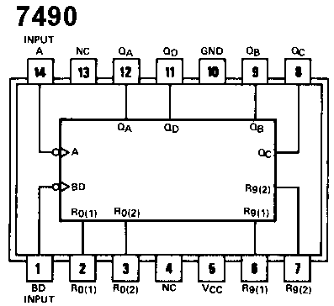

R01 and R02 are the reset inputs, when these are activated counter output goes to 0000. S91 and S92 are the set inputs to the counter, when these inputs are activated counter output goes to 1001. Thus finally, it gives the output as BCD to the next IC7447. It is also known as decimal counter or decade counter.

**IC7447**

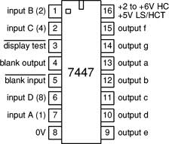

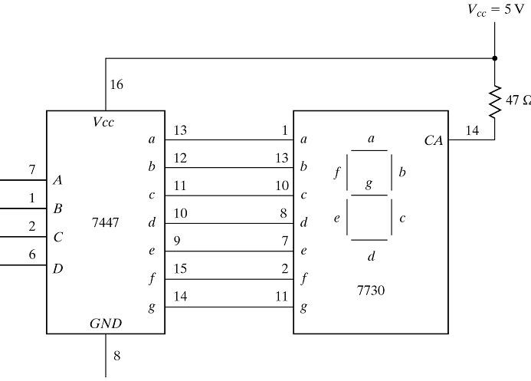

The 7447 IC is a decoder that is connected to the seven segment display.

Its function is to light up the proper segments of the display when binary – coded – decimal numbers BCD are applied to its input leads.

Thus it takes the output from the previous IC 7490 and then converts it into decimal form.

It is also known as BCD to decimal converter.

The output from the IC 7447 is given to the seven segment display.

**IC555**

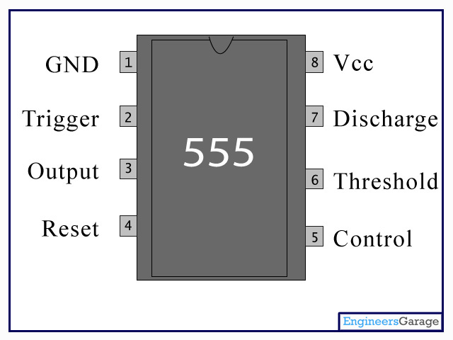

The 555 has three operating modes:

* **Monostable** mode: In this mode, the 555 functions as a "one-shot" pulse generator. Applications include timers, missing pulse detection, bounce free switches, touch switches, frequency divider, capacitance measurement, pulse-width modulation and so on.
* **Bistable** mode or Schmitt trigger: The 555 can operate as a flip-flop (electronic circuit that alternates between two output states) if the Discharge pin is not connected and no capacitor is used. Uses include bounce-free latched switches.
* **Astable** (free-running) mode: The 555 can operate as an oscillator. Uses include LED and lamp flashers, pulse generation, logic clocks, tone generation, security alarms, pulse position modulation and so on. The 555 can be used as a simple ADC, converting an analog value to a pulse length. E.g. selecting a thermistor as timing resistor allows the use of the 555 in a temperature sensor: the period of the output pulse is determined by the temperature. The use of a microprocessor based circuit can then convert the pulse period to temperature, linearize it and even provide calibration means.

**IC555 IN MONOSTABLE MODE**



* In the monostable mode, the 555 timer acts as a "one-shot" pulse generator.
* The pulse begins when the 555 timer receives a signal at the trigger input that falls below a third of the voltage supply.
* The width of the output pulse is determined by the time constant of an RC network, which consists of a capacitor (C) and a resistor (R).
* The output pulse ends when the voltage on the capacitor equals 2/3 of the supply voltage.
* The output pulse width can be lengthened or shortened to the need of the specific application by adjusting the values of R and C.
* While using the timer IC in monostable mode, the main disadvantage is that the time span between any two triggering pulses must be greater than the RC time constant.

**IC555 IN ASTABLE MODE**



* In astable mode, the 555 timer puts out a continuous stream of rectangular pulses having a specified frequency.
* Resistor R1 is connected between VCC and the discharge pin (pin 7) and another resistor (R2) is connected between the discharge pin (pin 7), and the trigger (pin 2) and threshold (pin 6) pins that share a common node.
* Hence the capacitor is charged through R1 and R2, and discharged only through R2 since pin 7 has low impedance to ground during output low intervals of the cycle, therefore discharging the capacitor.
* In the astable mode, the frequency of the pulse stream depends on the values of R1, R2 and C.

**SEVEN SEGMENT DISPLAY**

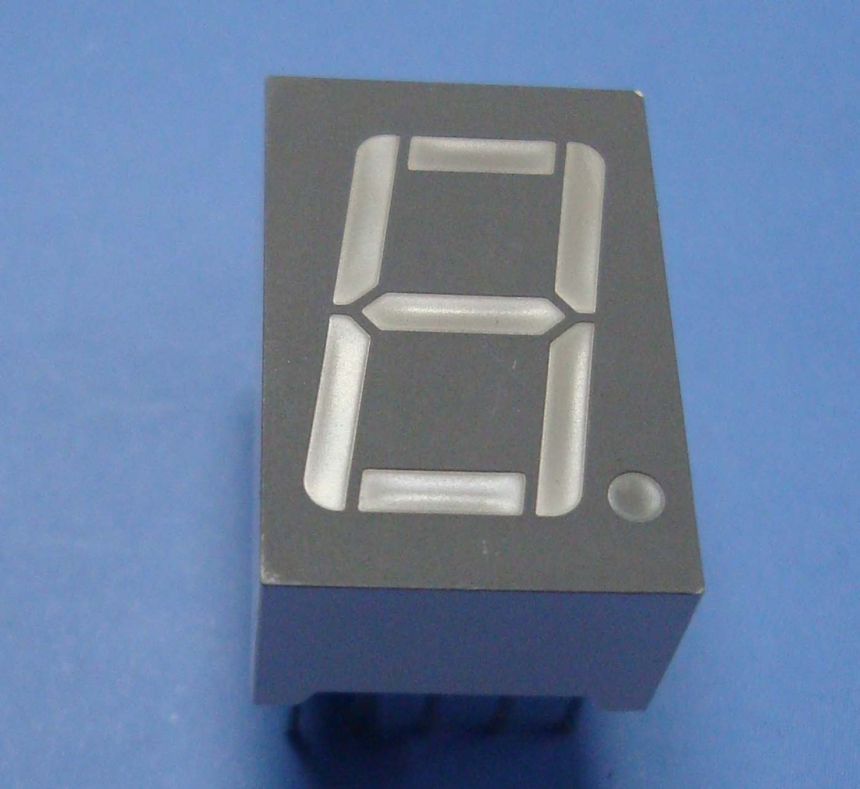

Inside the seven segment display, there are 8 led’s which glow one by one or all together depending on the pin upon which it is supplied the power.

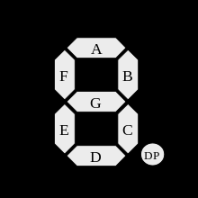

All 128 possible states of seven segment display



* A **seven-segment display** (**SSD**), or **seven-segment indicator**, is a form of electronic display device for displaying decimal numerals that is an alternative to the more complex dot-matrix displays.
* Seven-segment displays are widely used in digital clocks, electronic meters, and other electronic devices for displaying numerical information
* In practice current limiting resistors of about 330 ohms would be connected in series between the decoder/driver chip and each LED display segment to limit the maximum current flow.
* Seven-segment displays may use a liquid crystal display (LCD) or a light-emitting diode (LED) for each segment, or other light-generating or controlling techniques such as cold cathode gas discharge or vacuum fluorescent …etc.
* Liquid crystal displays (LCD´s) have one major advantage over similar LED types in that they consume much less power and now a days, both LCD and LED displays are combined together to form larger Dot-Matrix Alphanumeric type displays which can show letters and characters as well as numbers in standard Red or Tri-colour outputs
* The seven segments are arranged as a rectangle of two vertical segments on each side with one horizontal segment on the top, middle, and bottom. Additionally, the seventh segment bisects the rectangle horizontally.
* Hexadecimal digits can be displayed on seven-segment displays. A particular combination of uppercase and lowercase letters are used for A–F; this is done to obtain a unique, unambiguous shape for each letter (otherwise, a capital D would look identical to an 0 and a capital B would look identical to an 8).

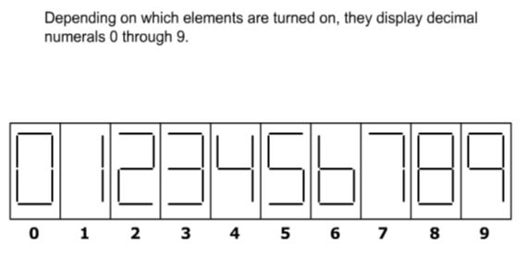

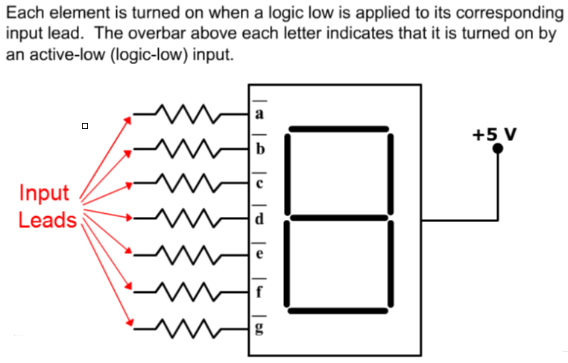

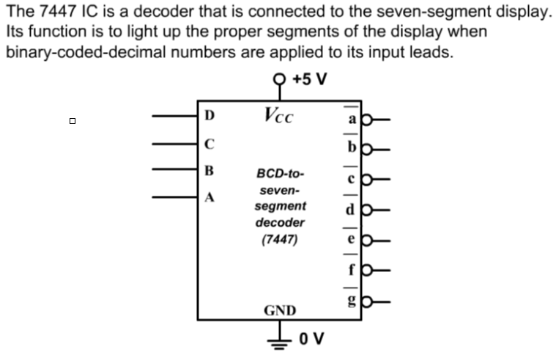

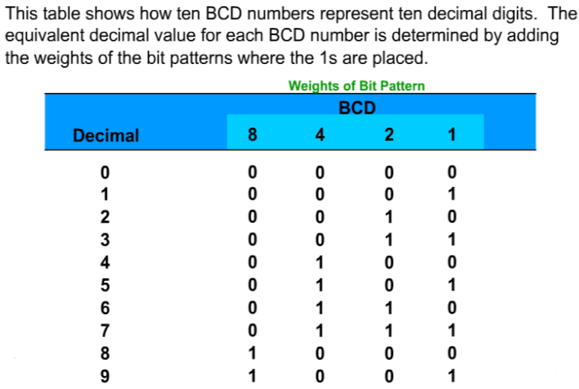

Hence a digital object counter is designed and implemented.

**REFERENCES:**

[**http://www.buildcircuit.com/digital-object-counter/**](http://www.buildcircuit.com/digital-object-counter/)

[**https://www.youtube.com/watch?feature=player_embedded&v=dP3V_7ovzW4**](https://www.youtube.com/watch?feature=player_embedded&v=dP3V_7ovzW4)

[**http://www.buildcircuit.com/mode-of-ne555-astable/**](http://www.buildcircuit.com/mode-of-ne555-astable/)

**WELCOME**